COMPREHENSION POETRY
Read the following poem carefully answer the questions that follow :-

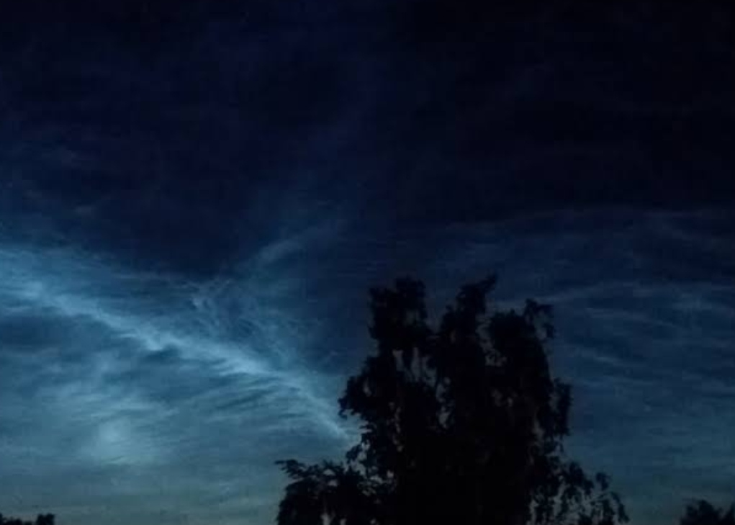
In the dark that falls before the dawn,
When the dew has settled on the thorn,
When the stars have been obscured by clouds,
A silence covers all things in shrouds.
No wind sighs in the mulberry tree,
No firefly glimmers wild and free,
A shadow has wrapped the night in gloom,
It’s silent as a deserted tomb.
All of a sudden a lapwing’s cry
Cuts the black silence as it flies by,
Again and again it slashes the dark
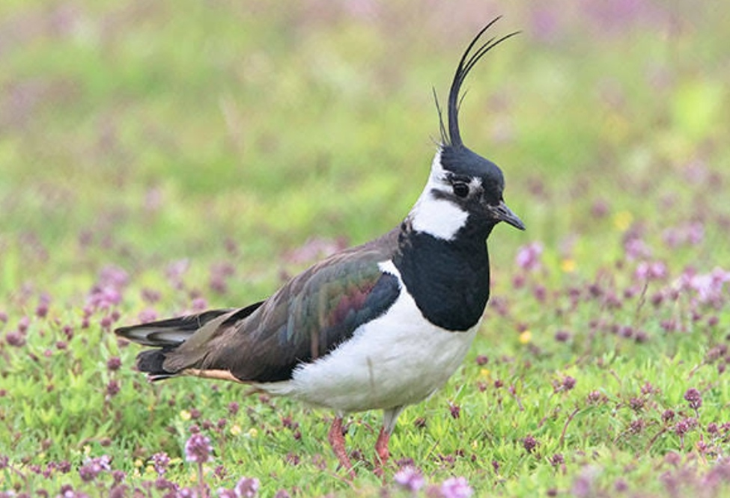
That haunts the empty, desolate park.
Anguish, sorrow pours from its throat,
It wings in the night, note after note;
I open my window so the light
Will flood the dark of this wretched night.
Why does it cry so miserably?
Why is it so solitary?
All I know is that loss and ache
Are left behind in the lapwing’s wake.

(a) When darkness falls there is ___________________________.
(i) complete silence everywhere
(ii) a shroud covering all things
(iii) the crying of the lapwing to be heard
(iv) gloom and desolation
(b) When does the lapwing come out?
(i) at dawn
(ii) at night
(iii) just before dawn
(iv) in the morning
(c) Why does the poet open the window?
(i) he can get some light
(ii) he can hear the lapwing
(iii) he can see the lapwing
(iv) he can get some air.
(d) What are the causes of the Lapwing’s misery?
(i) loneliness and gloom
(ii) loss and pain
(iii) darkness and loss
(iv) darkness and pain
(e) The lapwing’s cry fills the poet with _____________________ .
(i) longing
(ii) anger
(iii) unhappiness
(iv) joy
(f) What is the meaning of 'solitary'?
(i) together
(ii) united
(iii) lonely
(iv) simplicity
(g) What is compared to as "shrouds"?
(i) a cover
(ii) the darkness of the night
(iii) the clouds
(iv) none
(h) "It's silence as a deserted tomb" Which poetic device is used here?
(i) metaphor
(ii) personification
(iii) alliteration
(iv) simile
(i) What can be the appropriate title of the poem?
(i) The Lapwing
(ii) The Night
(iii) Loneliness
(iv) The Gloom
(j) What is the rhyme scheme of the poem?
(i) abab
(ii) abba
(iii) abcabc
(iv) aabb

